**1. Overview (Executive Summary)**

**1.1 *Name of game:*** Monkey Storm

**1.2 *Name of team*:** Storm

**1.3 *Names of team members*:**

Jae won Yang, Joel Abney, Jungbeom Lee, Shela Ngai, Zhengwei Wang (Michael)

**1.4 *Overview of Game*:**

**1.4.1 Overview of game concepts:**

Monkey Storm is an Android and iOS app game, designed in Unity3D, and written in C#.

It is designed to be a side-scrolling platformer. There are unlimited numbers of stages, but each stage consists of three levels. Each level has a different goal, but uses previous levels’ gameplay mechanics.

**1.4.2 Description of Game Play, Key Features, Win Conditions:**

Chacco, our hero, moves around the jungle by jumping from tree to tree by swiping across the screen. The levels will be on a fixed-size jungle map. In Level 1, the player will have to collect the appropriate number of branches. In Level 2, Chacco must defeat the evil monkeys known as the EMFA by throwing bananas. In Level 3, Chacco needs to run away from a bulldozer until it runs out of gas.

**1.4.3 Genre and Important Influences:**

The overall game design is TDS and inspired by Super Mario and “Minion Rush”. The bulldozer level is similar to “Temple Run”, but takes the side-scrolling aspect from games such as “Maple Story”.

**1.4.4 Outline of Background Story:**

Chacco gains intelligence due to radioactivity exposure in a laboratory located in the jungle. He escapes from the laboratory, and the mad scientists hunts Chacco down with an army of evil monkeys and bulldozers.

**1.4.5 Art Design:**

The art is aimed to be cartoonish so that players of all age can feel comfortable playing it.

It will use bright colors and expressive facial expressions to communicate a humorous atmosphere to the players.

**2.** **Game specification**

***2.1* *Rules and mechanics***

**2.1.1 Main character movements:**

Chacco moves left, right, up, and down by jumping from branch to branch, and tree to tree. The monkey has several possible movement types, including a **basic jump,** which allows the monkey to make a small jump to a nearby branch. Swiping the screen in a particular direction will make Chacco jump in that direction.

There is also a **small jump**, which requires the player to make a smaller swipe to move a small distance from its original position. This swipe is differentiated from the basic jump as this requires the swipe to be gentle and perfectly horizontal to the screen.

If there is a swipe up, then he will **jump** directly on top of the current branch that he is holding onto. If there is a swipe down, he will attempt to **drop down** from the current branch and land on a lower branch.

If branches are further than basic jump distance, then the monkey can use a **swing jump** which allows him to jump much further, grabbing hold of limbs that are otherwise out of reach. The player can execute a swing jump by swiping left and right, without lifting their finger off of the screen to build up momentum. As the momentum is building, Chacco will swing on the branch and then jump in the direction of the last point of contact, when the finger is being lifted off of the screen.

Chacco can make one jump while holding onto a limb. The next jump should be allowed only after Chacco grabs or lands on a new branch. He will then grab a branch in the air if he gets within a certain radius of the branch.

Because Chacco needs to collect branches, the monkey can break off the branches by **shaking the branches**. The controls to shake the branches are quick tapping motions. Once the player taps enough times, the branch will come off and Chacco will carry the branch.

Chacco can also **throw bananas** by swiping in the direction the EMFA monkeys are in only if Chacco has bananas in his possession. Otherwise, the swiping motion will just result in a jump motion. To jump while holding bananas, the player must swipe anywhere on the screen but from Chacco, otherwise if the player’s finger begins on Chacco’s position, Chacco will just end up throwing bananas. The banana will be shot from Chacco’s position and will react to gravity, slowly falling and will collide with interactible limbs. The monkey will also react to gravity. If he misses his branch, he will fall and take damage from the collision.

**2.1.2 The objects other than main character:**

The **jungle** is the main backdrop image in the game. There are multiple images of the

jungle set to look like they are at different distances. Each layer of jungle will move at

different speeds as Chacco moves through the world, giving the illusion of

depth in the background jungle images.

The first layer of **trees** are placed as map component which have branches and limbs. The trees themselves will not be interactable, but will be in focus and not appear to be in the distance. Branches are placed with different distances and heights on each foreground tree.

**Branches** are the most important component, aside from Chacco himself, which will be the base of Chacco and the EMFA’s movement. The player can even break off the branches which is essential to the first level. They will spawn items that Chacco will need to collect.

The **bananas** will be used as weapons against the EMFAs. They will be thrown at an enemy monkey, and inflict damage if it makes contact. The number of bananas on branches will be different and random. A branch may spawn one banana or five bananas.

**Enemy monkeys** will follow the main character, jumping from branch to branch in the direction that Chacco is in to try to catch him. Damage is inflicted if Chacco makes contact with these enemy monkeys. The enemy movement is based on AI that randomly selects a branch that is close to Chacco, and then the enemy will jump to that branch. They start from a predetermined starting point, wait a short amount of time to make a decision, and then finally move in hopes of catching Chacco. These monkeys collectively are known as the Evil Monkey Faction Army (EMFA).

The **bulldozer** is pacemaker of the game. It launches from the left portion of the screen and moves to the right tearing down all the trees in its path. The bulldozer will continue to move forward until it runs out of fuel. It chases Chacco and forces Chacco to make quick decisions as to where to jump in an attempt to escape the destructive fate of the jungle.

**2.1.3 Interaction between objects:**

**Chacco** will move via **branches**;climbing up, dropping down, jumping from one branch to another, and swinging from branch to branch. This is the only way for the monkey to move around the world and is a main component of the game. If Chacco misses, he falls to **ground** and takes damage from the impact. When this happens, the hit points of Chacco is reduced, and Chacco automatically respawns to the nearest branch.

Chacco can break branches and collect them. The collected branches are tracked in the information banner found along the top of the screen. Chacco can collect **bananas** by colliding with them through normal movements, and the collected bananas will also be tracked and displayed along the top information banner. The bananas can be thrown in any direction in an attempt to hit the EMFA. The bananas will use basic physics and respond to gravity by increasing its velocity towards the ground.

The **EMFA** will interact with branches and trees similarly to Chacco. They can also interact with Chacco himself, as if they collide, Chacco will take damage. If the EMFA collides with a banana, they will take damage instead. Just like Chacco, if the EMFA jumps on a weak branch then they can fall to the **ground** and take damage. When they get knocked out after being hit a certain number of times, they will fall to the ground, but continue to fall out of view of the camera, so the player cannot see them.

The **bulldozer** always moves on the **ground** from left to right until it runs out of fuel, and it does not take any damage. When it collides with the **trees**, the trees will topple over with its **branches** falling off and they will continue to fall until out of camera view. If enemies or other objects in the scene collide with the **bulldozer**, they will get knocked out and fall off the scene in the same manner.

**2.1.4 Winning Conditions**

There is no ultimate conclusion to the game, as stages just get harder and harder. Each stage contains three levels, and each level has a unique win condition. To complete a stage you must successfully conquer all three levels.

In Level One, Chacco needs branches to build his shelter after the exodus, the monkey needs to **collect the appropriate number of branches** according to the level’s guidelines, and the speed at which the branches are to be collect will also depend on the stage that the level is being played in. The easier the stage, the easier the level will be. The further the player progresses through the game, the number of branches needed to be collected will increase.

In Level Two, Chacco needs to **defeat the enemy monkeys by hitting them with bananas,** which can be collected during the game. The player will need to guide Chacco around the map to collect these bananas, while avoiding the EMFA. Every time the EMFA unit is hit by a banana, he will change colors. If you hit the EMFA enough times, he will be knocked out of the trees. Once all the EMFA monkeys on the map are defeated, Chacco will win the level.

Lastly, in Level Three, the player will **decide quickly how to move** Chacco and which path to take while avoiding the bulldozer. The bulldozer keeps removing the trees until it runs out of fuel. Chacco will run away from the bulldozer by choosing the right place to move in order to escape his destruction. If Chacco survives until the bulldozer runs out of fuel, then the player wins the level and moves on to the next stage. The next stage will restart at Level One, but it will be more challenging.

**2.1.5 Losing Condition**

There are three losing conditions, one for each level. In the first level, if the player does not collect the required number of branches before his health runs out, then the player loses and must restart the level again.

In the second level, Chacco must not let the number of his hearts drop to zero. He will need to avoid the EMFA to succeed. If he fails to do so, he will lose a heart every time his character collides with the enemy monkey. If Chacco loses all of his hearts, then the player loses and will have to restart the level.

Similarly, in the third level, if the bulldozer hits the monkey, he will fall to the ground and lose a heart. If he still has remaining hearts, he will bounce back up to the nearest tree branch that hasn’t be reached by the bulldozer yet. If the player loses all of his hearts, then the player will lose and must restart the level.

Another way to lose hearts is to fall to the ground. This can happen in any level as Chacco will jump from branch to branch to traverse the map. If Chacco’s hearts reach zero after colliding with the ground, then the player automatically loses and must restart the current level.

***2.2 Artwork and User Interface***

The target audience of our game is everyone regardless of age, so we would like to make our graphics as friendly as possible. The artwork and atmosphere is cartoonish, which gives off a “fun for everyone” sort of feeling. Colors will be bright and cheerful, with no dark shadows. The game itself will give off a feeling that it doesn’t take itself too seriously, and is just played for fun.

Characters will have exaggerated expressions to make it seem funny and entertaining. Chacco will be drawn as a cute monkey with light, friendly colors while the EMFA monkeys will be darker with meaner expressions to signify that they are the bad guys.

Level One Sketch

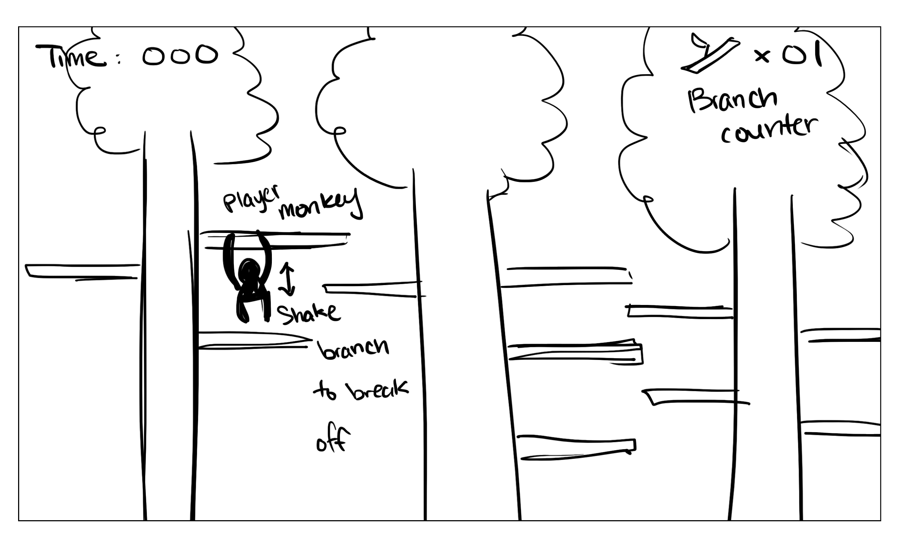

Level Two Sketch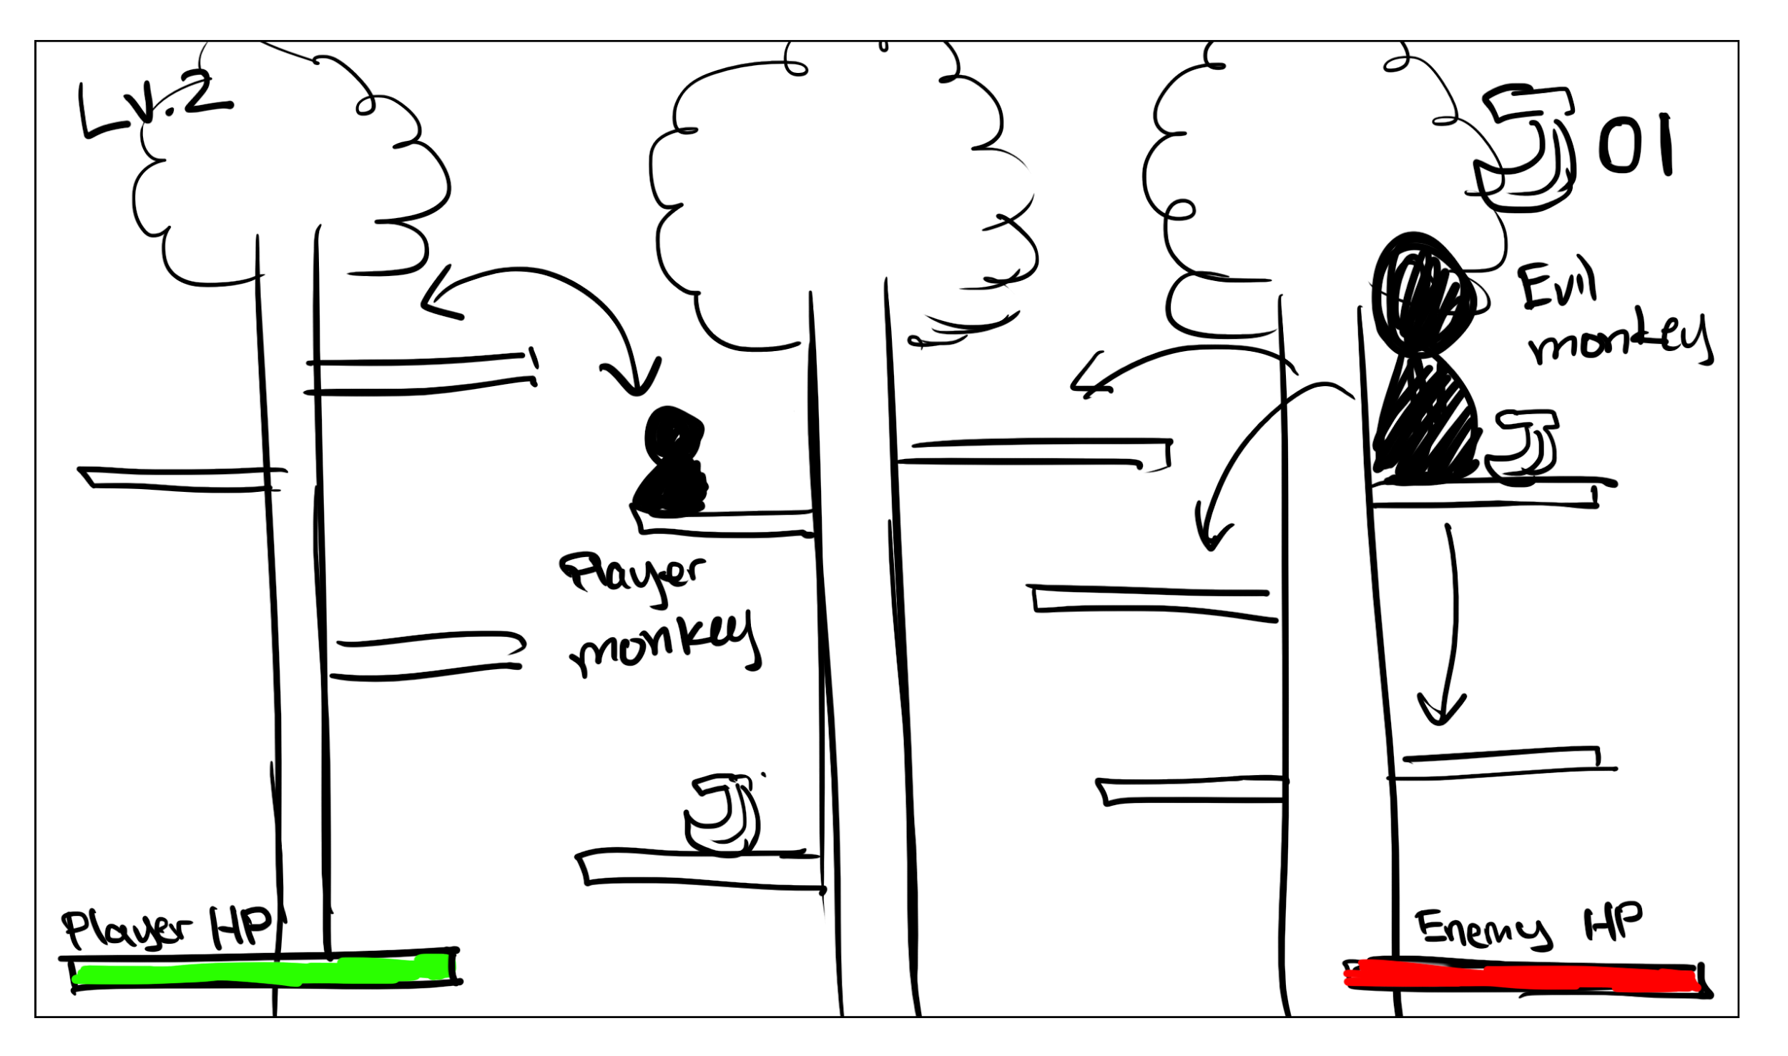

Level Three Sketch

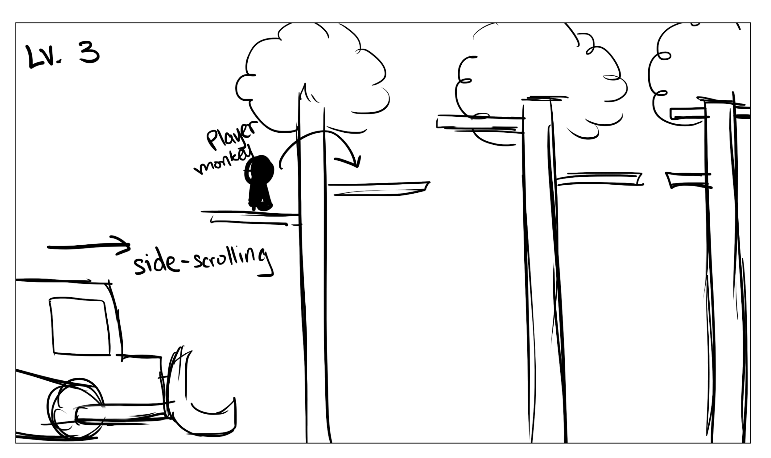

UI: Start Menu sketch

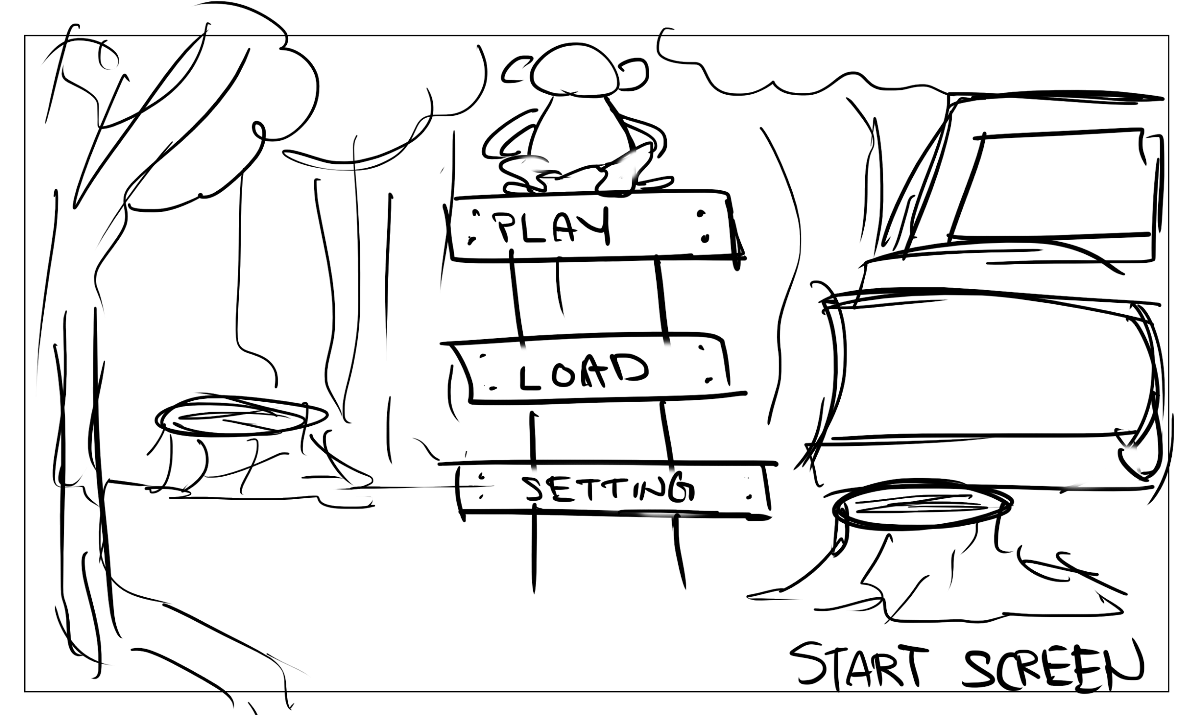

UI: Load Files Screen sketch

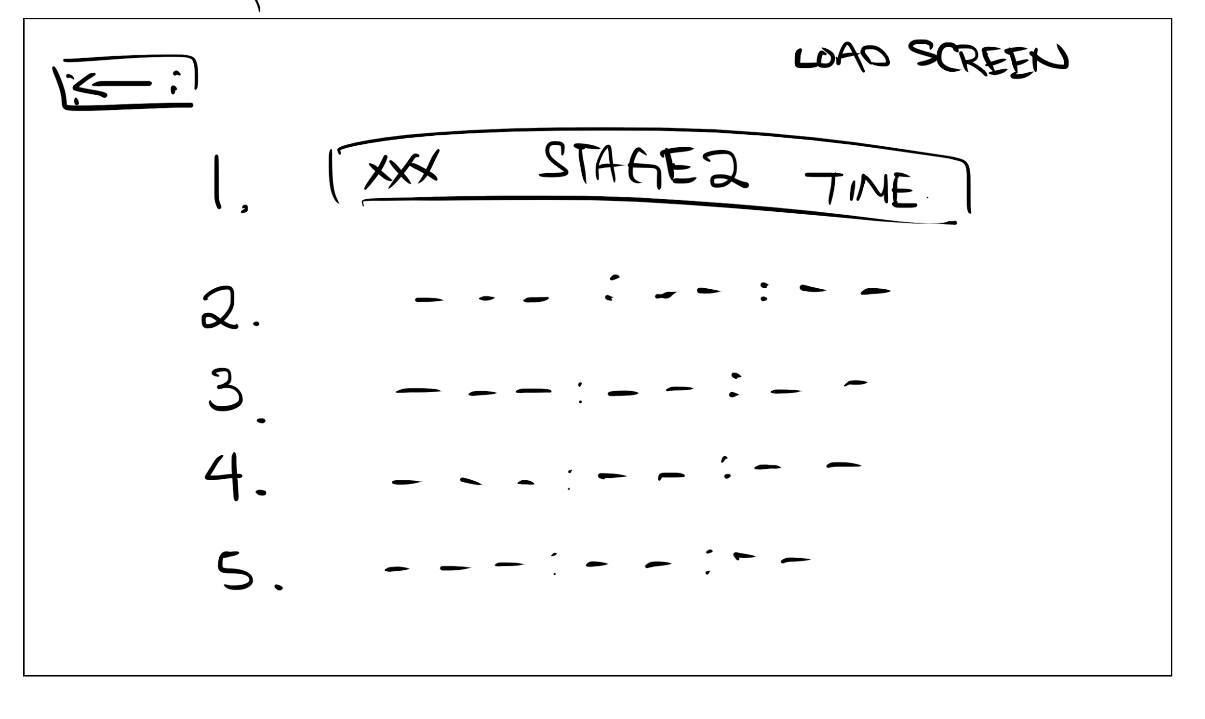

UI: Settings sketch

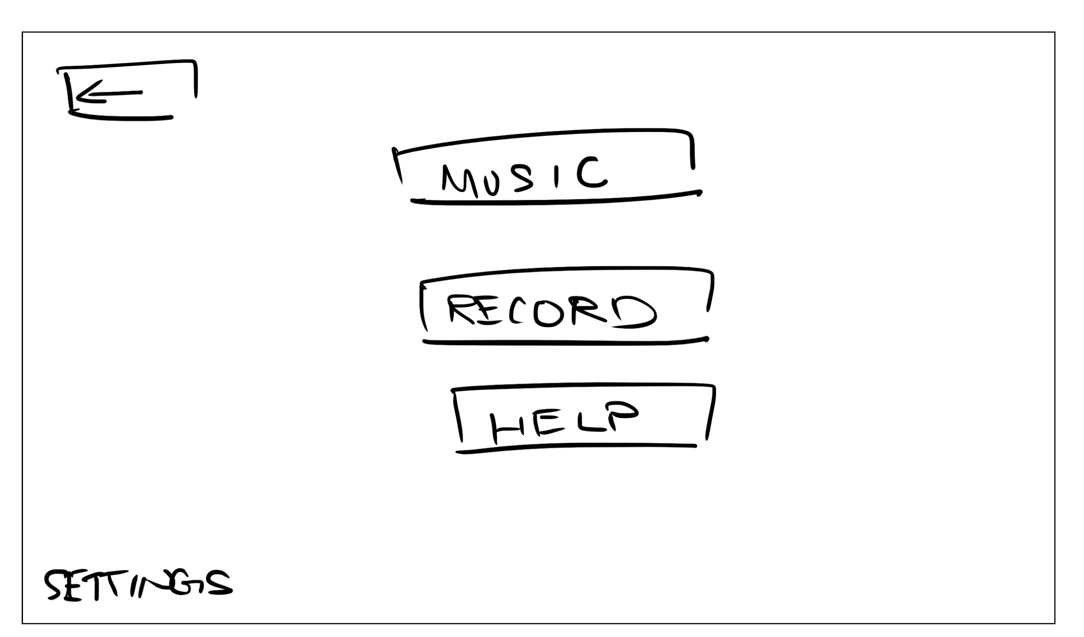

UI: Loading Game Screen sketch



The forest

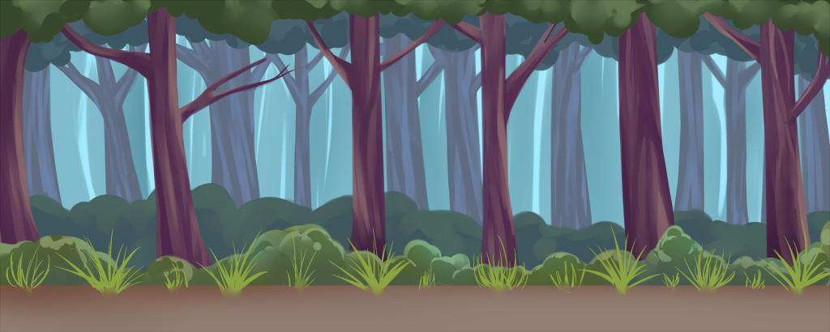

The start menu picture

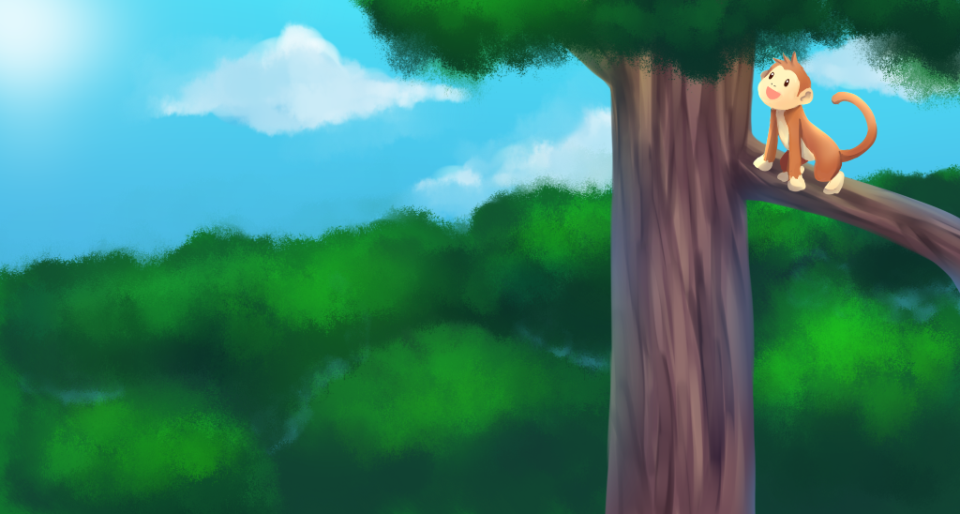

App button to start game from device’s menu



***2.3 Game Play and Balance***

**2.3.1 UI**

There will be six options that player can choose when the game is launched. They are **Start**, **Load**, **Options**, **Credit**, **Help**, and **Quit**. Player can start new game with the Start option. The Load option means that the player can start the game at a level that was accomplished previously. In Options, the player can adjust the brightness, music, and sounds. The Credit option will show the team name, team members, and their tasks. Help will show the winning condition, losing condition, and how to control the monkey. The Quit option will allow the player to quit the game.

Examples of the UI:

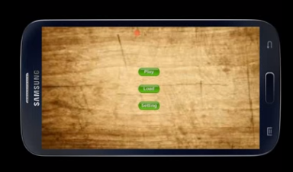

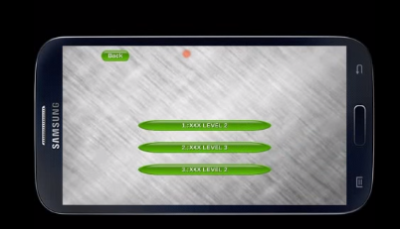

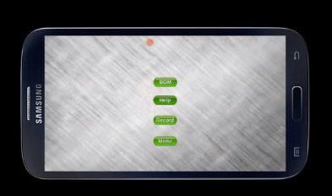

**2.3.2 Game Play Controls**

The controls are driven by swipe and touch gestures. To move Chacco, the player will simply swipe in the direction he or she wishes for the monkey to move and the monkey will then attempt a movement in that direction. The player can also, make Chacco jump to further branches by moving their finger back and forth on the screen without breaking contact. This will cause the monkey to sway and gain momentum. Once the finger is lifted, the monkey will make a jump in the direction of the finger’s last placement on the screen.

In order to break branches and leaves off of the trees, the player can move their finger up and down in a rapid motion or swipe in a rapid circular motion. The branches will get loose and eventually break free of the tree under these conditions.

The technique used to throw the bananas is the same as the jumping motions, but for Chacco to throw bananas, he must first have bananas in his possession, and the player’s finger must begin on Chacco. Otherwise, Chacco will only jump to the position the player’s swipes direct to.

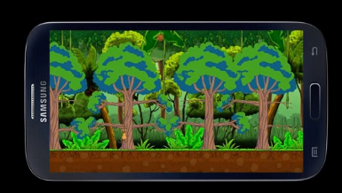

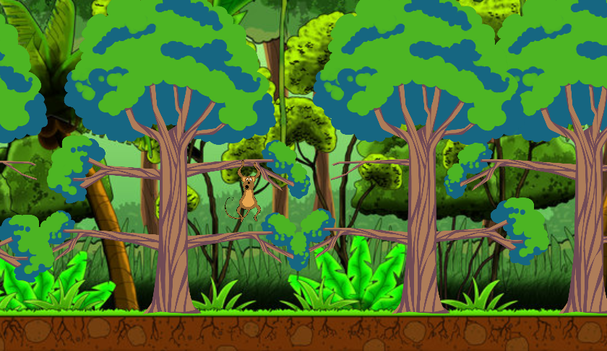

**2.3.3 Pause Menu**

The player can **pause** the game during game play, when he or she opens the menu by pressing the menu button. The menu will have the same options as the UI part, but there will also be a **resume** button. The resume button will unpause the game and close the pause menu.

***2.4 Music and Sound***

**2.4.1 BGM:**

BGM will be looped continuously until the game is over. The ambient noise will be **rainforest sounds**, such as crickets and birds chirping in the distance. Its volume can be adjusted in options menu, and the ambient sound can also be toggled on and off from the options menu.

**2.4.2 SFX (Sound Effects):**

The **monkey sounds** will be played during several situations. When the Chacco or the EMFA (**gorilla sound)** takes damage, they will make a yelping sound. Chacco will make a happy noise when he collects bananas and a similar sound when he throws them. There will be different **swooshing sounds** for Chacco and the EMFA. The limbs and branches will make a rustling sound when either monkey jumps on them and a cracking sound when they are about to break or are actually breaking. The **tractor sound** will be played louder when the bulldozer is close to Chacco, and it will fade as the monkey gains some distance. The trees will make a crashing noise as the bulldozer sends them to the ground. A **branch shaking sound** will be played when Chacco shakes the branch to collect it for his house. Collecting branches and bananas will produce a subtle **ping sound.** **Celebration** noises will be played when Chacco finishes the winning condition. A **defeating sound** will be played when the losing condition is met. A **boing sound** may be played whenever a button is pressed. Theses sounds volumes can be adjusted within the options menu. They can be also be toggled on and off in the options menu.

Our sound effects are all from free sources provided by a variety of producers on freesounds.com, soundbible, and findsounds.com.

|  |  |  |
| --- | --- | --- |
| **Sound Name** | **Artist** | **Source** |
| Rainforest | GlorySunz | [Soundbible.com](http://soundbible.com/1818-Rainforest-Ambience.html) |
| Monkey | Findsounds | [Findsounds.com](http://www.findsounds.com/ISAPI/search.dll) |
| Gorilla | Soundbible | [Soundbible.com](http://soundbible.com/1149-Gorilla.html) |
| Treehouse | Tristan_Lohengrin | [Freesound.org](https://freesound.org/people/Tristan_Lohengrin/sounds/250391/) |
| Tractor | videog | [Freesound.org](http://www.freesound.org/people/videog/sounds/149193/) |
| Branch shaking | j1987 | [Freesound.org](https://freesound.org/people/j1987/sounds/106114/) |
| Jump | michael_kur95 | [Freesound.org](https://freesound.org/people/michael_kur95/sounds/196770/) |
| Boing | plingativator | [Freesound.org](https://freesound.org/people/plingativator/sounds/188869/) |
| Drum | Sound_Designer_105 | [Freesound.org](http://www.freesound.org/people/Sound_Designer_105/sounds/182515/) |
| Swoosh | Pogotron | [Freesound.org](http://www.freesound.org/people/Pogotron/sounds/60835/) |
| Celebrate | xtrgamr | [Freesound.org](http://www.freesound.org/people/xtrgamr/sounds/239594/) |

***2.5 Background Story***

There is a secret research center located in the jungle where there are evil scientists who are researching on how to produce super soldiers. To produce these super soldiers, the evil scientists uses animal test subjects. The modified animals are aggressive and easily controlled by the scientists.

The scientists use radio-rays to modify the animals, and as a result, they are in constant pain. Naturally, the pain leads to the aggression. The evil scientists have experimented with several animals, including dogs, cats, birds, and reptiles. However, there is a 80% success rate with monkeys. With monkeys as their successful test subjects, theses mad scientists create an evil monkey army. These collective monkey soldiers are named EMFA, which stands for the Evil Monkey Faction Army. However, the EMFA loses their intelligence so that the scientists are able to control them more easily, but they lose their ability to use tools.

With the loss of intelligence, the evil scientists experiment further to gain it back. From this research, our main character Chacco appears. Chacco has high intelligence, but he has no fallen under the evil scientists’ control yet. During the middle of a painful experiment,a huge earthquake attacks the research lab. Chacco and some EMFA units manages to escape during the earthquake.

Now that Chacco has seen the outside world and knows how beautiful it is, he gets an ambitious dream. This ambitious dream is to build a kingdom and prosper in it. To accomplish the dream, Chacco needs to build his shelter, defeat the EMFA who are spread out in the jungle, and run away from the mad scientists who plan on destroying his home. The mad scientists hire outsiders to chase and catch their runaway experimented monkeys. These hired chasers uses bulldozers as they do not care for the jungle, and they want to catch the monkeys so they can get paid and do whatever they want with their money.

Now, the player’s goal is help Chacco achieve his dream. Player will collect branches to build a shelter. Unfortunately for the player and Chacco, they are interrupted before they can build a shelter and are attacked by the EMFA. Therefore, the player and Chacco will have to collect bananas and defeat the EMFA with them. And even more tragically, the chasers find Chacco shortly after destroy his hard work.

Chacco escapes the jungle after the bulldozers and finds a new place to live. But history repeats itself, and he will have to repeat this unfortunate life forever.

***2.6 Characters***

|  |  |
| --- | --- |
| Chacco: a bright energetic monkey who dreams of living in his own kingdom |  |
| Enemy monkey: members of the Evil Monkey Faction Army (EMFA). They don’t know how to think for themselves and follow orders blindly. |  |
| Bulldozer: they just want to catch the monkeys and go home with their money. |  |
| Banana: Chacco’s weapon of choice |  |
| Group of bananas: more bananas for fire power! |  |
| Tree: Chacco’s main (and only) source of materials for building his shelter |  |
| Tree Branch 1 (left) |  |
| Tree Branch 1 (right) |  |
| Tree Branch 2 (left) |  |
| Tree Branch 2 (right) |  |
| Tree Branch 3 (left) |  |
| Tree Branch 3 (right) |  |

***2.7 Levels***

Each stage consists of three levels in the game. For each consecutive stage, map sizes will increase as the challenges increase in difficulty. This will lead to more branches, more trees, and the paths will become more maze-like. The bananas will be spawned farther apart, making it harder to get to them. The angry monkeys will become smarter or show up in pairs, and the bulldozer will be faster and/or have more fuel.

**2.7.1 Level One: Build a Shelter!**

The player monkey has found a nice place to construct a home and he has to climb from

tree to tree in order to find interactible leaves and branches that he must collect to build a shelter. The first level will be a tutorial of the basic game mechanics and walk the player through an interactive learning process.

**2.7.2 Level Two: Fight for Territory!**

The player will have to navigate around a larger, aggressive monkey in a battle for territory. In order to win the right to stay in his new home the player will have to collect bananas from the trees and throw them at the large monkey until he drives him away. Unity sliders will be used to implement HP bars for both EMFA and Chacco.

**2.7.3 Level Three: Run for Your Life!**

A bulldozer plows through the jungle, destroying the trees and forcing you to continuously and swiftly jump from limb to limb until you escape. In order to survive the bulldozer, the player will need to continue to outrun the bulldozer and strategically dodge obstacles, such as large gaps between trees, until the bulldozer runs out of fuel. Have a fuel gauge for the bulldozer instead of a timer to show progress.

***2.8 Scripts***

**2.8.1 Main character:**

**Player Monkey (Chacco):**

“This is where I start!”

“Ahhh, I need bananas right now!”

“Need to run, shhh.”

**2.8.2 Researchers or chasers (bulldozer):**

**“**Fear me, Jungle! I am the destroyer! HAHAHA.”

**2.8.3 Others (Angry monkeys):**

“GRRRR!”

“OOOH-OOH-AAH-AAAH!!!!”

***2.9 Cutscenes***

There are no plans for any cutscenes at this time.

***2.10 Artificial Intelligence***

Artificial Intelligence (AI) applied to the Monkey Storm game is basically based on predefined rules. Those rules are necessary to decide how EMFAs play their roles in the game. EMFAs are supposed to stop a player from finishing the game as quickly as possible.

Before creating those rules, two preconditions are established as follows:

First, the game’s level of difficulty depends on how the programmer adjust two things: the numbers of the EMFA units and their moving speed. Essentially, EMFAs are created according to an equation that enables to decide how many starting spots are to be initiated with help of a variable *k* offering a range of 0.4 to 0.6. The following equation calculates the number of starting spots where EMFAs start to play at the beginning of a game.

Starting Spots (SS) = Floor (T * k1), T >= 4 (1)

where T is the number of tree, k stands for a variable in 0.4 <= k1 <= 0.6.

For example, given k1 = 0.6 and T = 6, SS can be 3.6 ~= 3 because Floor function gives 3.

Second, there are several playing patterns for EMFAs to act on in the game. Each individual monkey is programmed acting on one of the three patterns. A EMFA unit can jump around from tree to tree. Another pattern is to keep moving up and down on the same tree. The last pattern is jumping on the spot over a branch. In order for a EMFA unit to jump from tree to tree, it has to have a new location where it lands for next move. That new location must be a tree in front of behind the current tree that it stands on. The programmer can calculate geometric distance between tree1 and tree2, or tree1 and tree3 if tree1 is where a EMFA stays.

For example, suppose that tree1 and tree2 have locations of (x1, y1) and (x2, y2) respectively. Its distance is valid only if x and y are both positive integers. Every jump that a EMFA unit makes must be less than or equal to a particular value *d* = P, 0 < *d* <= P. Thus, a EMFA unit cannot jump up and land on a tree having larger distance than P.

And lastly, trees that a EMFA unit can jump around are selected according to the following:

Possible Spots (PS) = Floor (SS * k2), k2 = 0.8 (2)

Therefore, the programmer can control the game level of difficulty by adjusting k1 values because k1 values determine tree numbers. It sequentially creates EMFA units based on equation (1). Then, each EMFA unit acts on the pattern selected by random. In addition, we can possibly plan to reward the rules that catch a player to get highly rewarded rules selected more on determining which rule to be applied to each monkey action pattern in the end.

**3.** **Technical Specs**

***3.1 Game rules***

For character movements, the gravity is currently set as 5.0. There are 8 movements for playable character, such as jumping left, jumping right, jumping up, move left, move right, drop down, shaking, and swing jump. For the left and right jump, it has values as (x-axis = 10.0, y-axis = 15). It allows Chacco to jump from branch to branch, which are the same height level. Jumping up will multiply 1.5 to the y-axis value in order for Chacco to gain access to higher branches. Moving left and right is an adjustment movement that Chacco can move the same branch in order to jump to next one. Shaking will be a jump but has little value as y-axis = 0.1 to show that Chacco is shaking the branch. The swing jump allows Chacco to jump higher and further.

Chacco will start with 4 hearts that will allow Chacco to be caught by EMFA about 4times. Similarly, the EMFA monkeys will be defeated by being hit by bananas 3 times. As the game progresses to more difficult stages, the number of hits needed to defeat the EMFAwill increase.

***3.2 Programming Languages, Including Compiler and Emulator***

C# is used to create scripts that control characters in the game. Scripts created are edited, compiled, and emulated in Unity.

***3.3 Libraries That Will be Used***

Unity implemented libraries such as Rigidbody2D, Input, and Collider2D.

***3.4 Game Engine***

Unity is used in making this game in this project, as it provides various existing libraries. With the help of Unity, programmers are easily able to create a game, especially since Unity provides Assets that includes predefined classes. Programmers can build up from the scratch using those predefined classes in the library. In addition, Unity allows for animation effects using scripts that programmers implement along with specific actions using C# and existing methods in the Animation class. Programmers can also draw backgrounds, define characters, and specify their actions using scripts written by C#.

***3.5 Target Hardware and Operating System***

The target devices are tablets and phones running iOS or Android operating systems. The ideal target device would be tablets or iPads as they have a larger screen for players.

***3.6 Data Structures, Interfaces of ADTs and Classes.***

Not yet applicable.

***3.7 Exact Algorithms***

In Unity, each character has a green colored boundary with which the programmer can check if a collision between two different objects collide head-on. Simply speaking, programmers write a script to tell which objects collide by checking if their current position of each character is folded or not, by using the green-lined boundary location value. Once a collision occurs, it triggers an event that the programmer should deal with to see which objects are affected. In the game, collision occurs in two cases. One, a collision between the player monkey and the enemy monkey or bulldozer means a decrease in health for the player. The second case occurs when the monkey interacts with items such as the tree branches or bananas. In either case, player monkey can keep playing until the time limit is reached.

***3.8 Backup and Version Control Plans***

**3.8.1 Codes**

The team uses GitHub to maintain our work. GitHub is version control management software. We will upload our individual work when we work on our individual tasks. We created a _scene folder to store individual scenes. Furthermore, no two people can work on the same scene as it will overwrite the other person’s when it is uploaded onto GitHub.

**3.8.2 Assets (Resources)**

For artwork, we have a folder named _artwork to store in-game artwork from teammates or other sources. We will have more folders for sounds and musics when we implement those.

**3.8.3 Design Document**

We opened a Google Doc to write our design document. Each person can either edit the document and store our own copy locally on our machines before uploading it and making changes, or make changes directly to the document online. Google Docs automatically saves it and shows the changes being made in real time.

**4. Schedule and Personnel**

***4.1 Main Jobs*:**

**Jae won Yang:** programmer, first draft of doc, enemies and their AI dev.

**Joel Abney:** main programmer, task assigner, main designer, mostly design the game, introducing unity, GitHub, trello, third draft of document

**Jungbeom Lee:** programmer, document writer, first and second draft of document, main character dev

**Shela Ngai:** main artist; first draft of doc, first version of artwork, fourth draft of the document

**Zhengwei Wang (Michael):** programmer, document writer, pitch powerpoint,UI dev

***4.2 Writing History***

Version 1: Won Yang on Oct. 11, 2015

Version 2: Jungbeom Lee on Oct. 13 & 17, 2015

Version 3: Joel Abney on Oct. 18, 2015

Version 4: Shela Ngai on Oct. 20, 2015

Version 5: Jungbeom Lee on Nov. 1 & 3, 2015

Version 6: Shela Ngai on Nov. 3, 2015

Version 7: Shela Ngai on Dec. 6, 2015

***4.3 Future Schedule*:**

**Week 6**:

Jae won Yang:

* Figuring out how to implement AI part for our enemies

: routine calls and collision detection

Joel Abney:

* Find the bounds for the camera follow in level 1 and clamp the camera to stay within that range.
* Figure out how to fit more branches on the trees and to improve on the design of level 1.

Jungbeom Lee:

* figuring out how to detect shaking input. Implement shaking and swing jump movement.

Shela Ngai:

* Plan to finalize player monkey’s sprite
* Start on enemy monkey’s sprite
* Start and finish banana sprites

Zhengwei Wang (Michael):

* Connect Pause Menu With Game.
* Add Status Bar For the Game (Such As Hp bar, Scores..etc)
* Connect the Bar to the Game( Scores, HP.. will change according to the game)

**Week 7**:

Jae won Yang:

* Figuring out how to implement AI part for our enemies

: develop enemies’ movement up and down

Joel Abney:

* Begin designing level 2 and level 3, by mapping out where the trees will be setup and how to make the levels the right amount of challenging.
* Make the branches breakable from the trees and finish coding the rules for level 1.
* Complete the integration of the player monkey.

Jungbeom Lee:

* figuring out how to add animations of character. polish the movement by changing values.

Shela Ngai:

* Work on enemy monkey’s sprite animations
* Start on bulldozer animation sketches
* Sketch on UI background

Zhengwei Wang (Michael):

* Connect HP Bar to Chacco
* Modify Settings & Record UI

**Week 8:**

Jae won Yang:

* Figuring out how to implement AI part for our enemies

: adjust control part for all enemies

Joel Abney:

* Add the enemy monkey to level 2.
* Code the behavior and add the bulldozer to level 3.
* Apply winning/losing conditions and scoring to each level.
* Integrate the UI elements into all levels, such as the top banner, which shows the score and important player information.

Jungbeom Lee:

* QA and help other team members. preparing game pitch.

Shela Ngai:

* Finalize banana sprites
* Finalize bulldozer animation
* Work backdrop image for the background of the game

Zhengwei Wang (Michael):

* Finish Record & Save Functions
* Connect Load Functions to levels
* Modify all UI Background
* Add HP Bar For Bulldozer & Evil Monkey

**Week 9:**

Jae won Yang:

* Figuring out how to implement AI part for our enemies

: put everything together in the game to see if they work well

Joel Abney:

* Apply the sprite animations to the animated objects:
  + Player monkey movements
  + Enemy monkey movements
  + Bulldozer driving
  + Leaves shaking
  + Integrate the animated sprites into the game.
  + Finalize the level design by adjusting any inconsistencies and polishing the visual aspect of the game layout that might become corrupted due to changing the single sprites to animated sprites.

Jungbeom Lee:

* Preparing game pitch and other documents.

Shela Ngai:

* Work on Start Menu’s image
* Loading/waiting animations

Zhengwei Wang (Michael):

* Improve all UI buttons & canvas
* Improve UI canvas animations
* Add Canvas about the team

**FINAL WEEK:**

**Finish the project and the class!**